**Supplemental materials for the article “Integrating AI into Clinical Workflows: A Simulation Study on Implementing AI-aided Same-day Diagnostic Testing Following an Abnormal Screening Mammogram”**

**Figure S1**. The cost model diagram of a mammogram examination.

**Figure S2**. Design of the temporal validation of the baseline simulation model.

**Table S1**. Descriptions of discrete event simulation models.

**Table S2**. Simulation model parameters: the average number of patients per hour.

**Table S3**. Simulation model parameters: the percentages of examinations by hour.

**Table S4**. Validation of the baseline simulation model.

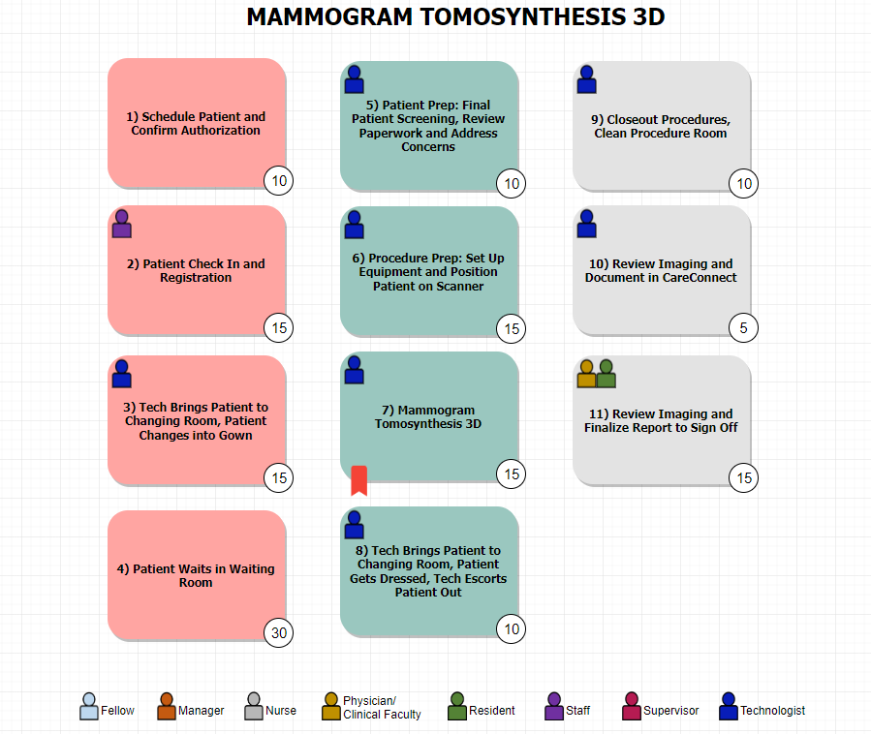

**Figure S1**. The cost model diagram of a mammogram examination.

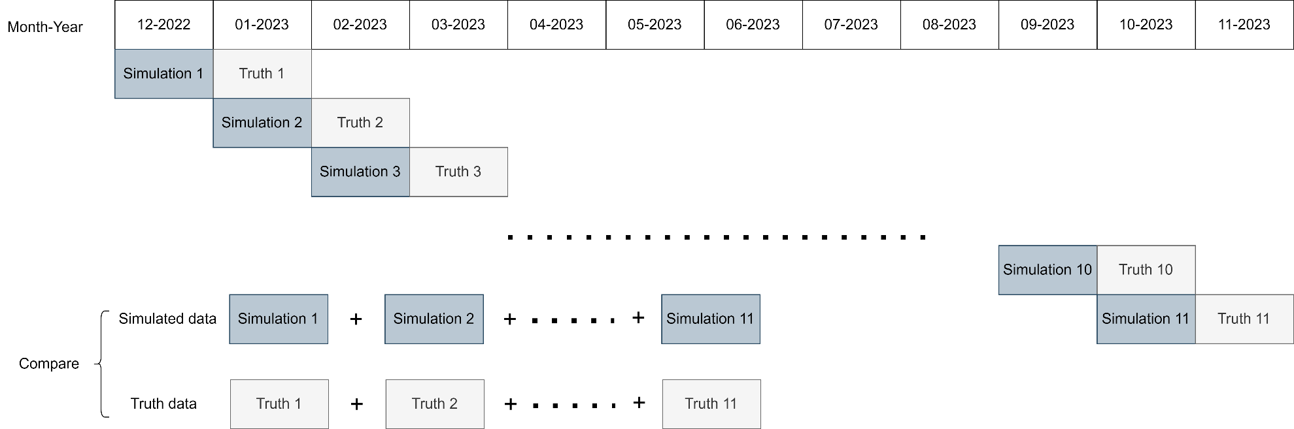

**Figure S2**. Design of the temporal validation of the baseline simulation model. The simulation was conducted by inputting the model parameters corresponding to a specific month, as illustrated in the figure.

|  |  |
| --- | --- |
| **Table S1**. Descriptions of discrete event simulation models. | |
| Name | Description |
| Operating hours | Time imaging center stops patient check-in and closes each day |
| Patient arrival | The patient arrives at clinic |
| Patient check-in | The patient checks in and fills out history on iPad |
| Public waiting room | The patient sits in the outer public waiting room |
| Consent room | Consent obtained by LVN/trainee for patients undergoing biopsies |
| Dressing room | The patient changes into a gown; The patient changes into street clothes and leaves the facility |
| Gowned waiting room | The patient waits in the gowned waiting room |
| AI assessment (revised workflow only) | The AI tool establishes preliminary results, confirmed by a radiologist if AI-flagged positive results |
| Screening mammography | The mammo technician walks the patient to a mammo room; The mammo technician performs a screening mammogram; The mammo technician cleans the mammo room |
| Screening US | The US technician walks the patient to a US room; The US technician performs a screening US The US technician cleans the US room |
| Diagnostic imaging | The mammo/US technician walks the patient to a/an mammo/US room; The mammo/US technician performs a diagnostic mammogram, diagnostic US, or diagnostic mammogram + diagnostic US;  The mammo/US technician cleans the mammo/US room |
| Diagnostic imaging review | The radiologist reviews the diagnostic images |
| Core needle biopsy | Consent obtained by LVN/trainee  The mammo/US/MR technician walks the patient to a/an mammo/US/MR room; The mammo/US/MR technician performs prebiopsy images;  The LVN/trainee positions, preps, and drapes the patient’s breast; The attending radiologist and trainee perform a biopsy; The LVN/trainee holds pressure (hemostasis) & explains post-biopsy care instructions; The US/MR technician transfers the patient to a mammo room and cleans the biopsy room; The mammo technician performs a post-biopsy mammogram, reviewed by a radiologist; The mammo technician cleans the mammo room |
| MRI (non-interventional) | MRI examinations are deemed irrelevant within the workflows |
| **Abbreviations:** LVN: licensed vocational nurse; AI: artificial intelligence; mammo: mammography; US: ultrasound; MR: magnetic resonance; MRI: magnetic resonance imaging. | |

|  |  |  |  |  |  |  |  |  |  |  |  |  |  |  |
| --- | --- | --- | --- | --- | --- | --- | --- | --- | --- | --- | --- | --- | --- | --- |
| **Table S2**. Simulation model parameters: the average number of patients per hour. | | | | | | | | | | | | | | |
| Hour |  | Average number of patients | | | | | | | | | | | | |
|  | 2022-12 | 2023-01 | 2023-02 | 2023-03 | 2023-04 | 2023-05 | 2023-06 | 2023-07 | 2023-08 | 2023-09 | 2023-10 | 2023-11 | 2023-12 |
| 7 am to 8 am |  | 6.09 | 6.08 | 5.87 | 5.81 | 5.76 | 5.85 | 6.32 | 5.84 | 6.58 | 5.35 | 5.54 | 5.46 | 5.87 |
| 8 am to 9 am |  | 7.73 | 6.62 | 7.52 | 7.30 | 7.48 | 8.77 | 8.84 | 8.64 | 9.62 | 8.96 | 9.14 | 8.69 | 8.30 |
| 9 am to 10 am |  | 7.09 | 6.42 | 7.00 | 7.22 | 7.32 | 8.62 | 8.64 | 8.16 | 9.19 | 9.00 | 9.36 | 8.81 | 8.11 |
| 10 am to 11 am |  | 6.73 | 6.12 | 6.17 | 6.74 | 6.72 | 6.88 | 8.16 | 7.16 | 8.54 | 7.85 | 8.79 | 9.62 | 7.50 |
| 11 am to 12 pm |  | 9.27 | 7.54 | 7.83 | 7.22 | 7.16 | 5.88 | 5.56 | 6.64 | 6.88 | 7.35 | 8.18 | 5.88 | 7.09 |
| 12 pm to 1 pm |  | 2.59 | 3.08 | 2.65 | 2.33 | 2.32 | 2.27 | 2.08 | 2.04 | 2.27 | 2.88 | 1.93 | 2.19 | 2.38 |
| 1 pm to 2 pm |  | 9.18 | 8.12 | 8.22 | 7.89 | 7.96 | 8.62 | 8.80 | 10.04 | 9.12 | 9.85 | 9.61 | 8.54 | 8.83 |
| 2 pm to 3 pm |  | 8.64 | 6.46 | 6.78 | 7.07 | 6.28 | 6.96 | 8.28 | 7.92 | 8.04 | 8.46 | 7.64 | 7.58 | 7.51 |
| 3 pm to 4 pm |  | 8.36 | 7.42 | 7.96 | 7.70 | 7.92 | 8.62 | 8.72 | 9.40 | 9.38 | 9.65 | 8.82 | 8.96 | 8.59 |
| 4 pm to 5 pm |  | 2.68 | 2.46 | 2.35 | 2.59 | 2.08 | 2.23 | 2.64 | 3.84 | 3.96 | 3.23 | 3.50 | 3.15 | 2.91 |

| **Table S3**. Simulation model parameters: the percentages of examinations by hour. | | | | | | | | | | | |
| --- | --- | --- | --- | --- | --- | --- | --- | --- | --- | --- | --- |
| Time | Exam type | 7 am to 8 am | 8 am to 9 am | 9 am to 10 am | 10 am to 11 am | 11 am to 12 pm | 12 pm to 1 pm | 1 pm to 2 pm | 2 pm to 3 pm | 3 pm to 4 pm | 4 pm to 5 pm |
| 2022-12 | Stereotactic-guided biopsy | 0.00 | 0.00 | 0.00 | 0.00 | 0.00 | 0.00 | 0.00 | 0.00 | 0.00 | 0.00 |
| MR-guided biopsy | 0.00 | 0.00 | 0.00 | 0.00 | 0.00 | 0.00 | 0.03 | 0.01 | 0.01 | 0.00 |
| US-guided biopsy | 0.00 | 0.00 | 0.12 | 0.10 | 0.02 | 0.00 | 0.04 | 0.04 | 0.00 | 0.00 |
| Diagnostic mammo | 0.02 | 0.07 | 0.03 | 0.03 | 0.06 | 0.33 | 0.03 | 0.02 | 0.01 | 0.00 |
| Diagnostic mammo + diagnostic US | 0.15 | 0.55 | 0.31 | 0.43 | 0.07 | 0.32 | 0.33 | 0.43 | 0.19 | 0.00 |
| Diagnostic US | 0.04 | 0.20 | 0.06 | 0.05 | 0.09 | 0.07 | 0.14 | 0.07 | 0.01 | 0.00 |
| MRI | 0.12 | 0.01 | 0.10 | 0.09 | 0.09 | 0.02 | 0.03 | 0.03 | 0.00 | 0.05 |
| Screen mammo | 0.66 | 0.16 | 0.36 | 0.30 | 0.50 | 0.26 | 0.38 | 0.38 | 0.41 | 0.95 |
| Screen US | 0.00 | 0.00 | 0.03 | 0.00 | 0.16 | 0.00 | 0.01 | 0.02 | 0.37 | 0.00 |
| 2023-01 | Stereotactic-guided biopsy | 0.00 | 0.00 | 0.00 | 0.00 | 0.00 | 0.00 | 0.00 | 0.00 | 0.00 | 0.00 |
| MR-guided biopsy | 0.00 | 0.00 | 0.00 | 0.00 | 0.00 | 0.00 | 0.06 | 0.00 | 0.01 | 0.00 |
| US-guided biopsy | 0.00 | 0.00 | 0.12 | 0.13 | 0.01 | 0.01 | 0.04 | 0.05 | 0.01 | 0.02 |
| Diagnostic mammo | 0.02 | 0.10 | 0.03 | 0.02 | 0.06 | 0.26 | 0.06 | 0.02 | 0.01 | 0.00 |
| Diagnostic mammo + diagnostic US | 0.24 | 0.50 | 0.28 | 0.36 | 0.10 | 0.39 | 0.31 | 0.35 | 0.13 | 0.02 |
| Diagnostic US | 0.01 | 0.19 | 0.07 | 0.07 | 0.01 | 0.03 | 0.12 | 0.09 | 0.02 | 0.00 |
| MRI | 0.10 | 0.01 | 0.12 | 0.10 | 0.11 | 0.03 | 0.02 | 0.02 | 0.01 | 0.02 |
| Screen mammo | 0.63 | 0.19 | 0.37 | 0.32 | 0.53 | 0.28 | 0.38 | 0.46 | 0.46 | 0.92 |
| Screen US | 0.00 | 0.02 | 0.01 | 0.00 | 0.18 | 0.00 | 0.01 | 0.01 | 0.36 | 0.03 |
| 2023-02 | Stereotactic-guided biopsy | 0.00 | 0.00 | 0.00 | 0.00 | 0.00 | 0.00 | 0.00 | 0.00 | 0.00 | 0.00 |
| MR-guided biopsy | 0.00 | 0.00 | 0.00 | 0.00 | 0.00 | 0.00 | 0.06 | 0.01 | 0.01 | 0.00 |
| US-guided biopsy | 0.00 | 0.00 | 0.11 | 0.10 | 0.01 | 0.00 | 0.03 | 0.04 | 0.01 | 0.00 |
| Diagnostic mammo | 0.01 | 0.07 | 0.02 | 0.01 | 0.07 | 0.28 | 0.04 | 0.04 | 0.02 | 0.04 |
| Diagnostic mammo + diagnostic US | 0.16 | 0.56 | 0.20 | 0.40 | 0.06 | 0.30 | 0.34 | 0.36 | 0.17 | 0.00 |
| Diagnostic US | 0.05 | 0.17 | 0.13 | 0.07 | 0.04 | 0.07 | 0.12 | 0.06 | 0.01 | 0.00 |
| MRI | 0.13 | 0.00 | 0.10 | 0.12 | 0.08 | 0.02 | 0.02 | 0.03 | 0.01 | 0.02 |
| Screen mammo | 0.64 | 0.16 | 0.39 | 0.27 | 0.57 | 0.34 | 0.38 | 0.46 | 0.40 | 0.94 |
| Screen US | 0.00 | 0.05 | 0.04 | 0.03 | 0.18 | 0.00 | 0.01 | 0.01 | 0.36 | 0.00 |
| 2023-03 | Stereotactic-guided biopsy | 0.00 | 0.00 | 0.00 | 0.00 | 0.00 | 0.00 | 0.00 | 0.00 | 0.00 | 0.00 |
| MR-guided biopsy | 0.00 | 0.00 | 0.00 | 0.00 | 0.00 | 0.00 | 0.06 | 0.00 | 0.01 | 0.00 |
| US-guided biopsy | 0.00 | 0.00 | 0.10 | 0.11 | 0.01 | 0.00 | 0.04 | 0.05 | 0.00 | 0.00 |
| Diagnostic mammo | 0.01 | 0.08 | 0.02 | 0.00 | 0.06 | 0.33 | 0.03 | 0.04 | 0.02 | 0.00 |
| Diagnostic mammo + diagnostic US | 0.20 | 0.50 | 0.27 | 0.38 | 0.09 | 0.33 | 0.25 | 0.41 | 0.11 | 0.00 |
| Diagnostic US | 0.02 | 0.21 | 0.11 | 0.04 | 0.01 | 0.05 | 0.17 | 0.05 | 0.02 | 0.00 |
| MRI | 0.10 | 0.01 | 0.09 | 0.10 | 0.10 | 0.00 | 0.02 | 0.02 | 0.01 | 0.01 |
| Screen mammo | 0.67 | 0.19 | 0.37 | 0.34 | 0.53 | 0.24 | 0.41 | 0.42 | 0.45 | 0.93 |
| Screen US | 0.01 | 0.02 | 0.03 | 0.03 | 0.19 | 0.05 | 0.01 | 0.01 | 0.38 | 0.06 |
| 2023-04 | Stereotactic-guided biopsy | 0.00 | 0.00 | 0.00 | 0.00 | 0.00 | 0.00 | 0.01 | 0.00 | 0.00 | 0.00 |
| MR-guided biopsy | 0.00 | 0.00 | 0.00 | 0.01 | 0.00 | 0.00 | 0.06 | 0.00 | 0.03 | 0.00 |
| US-guided biopsy | 0.00 | 0.00 | 0.10 | 0.09 | 0.04 | 0.00 | 0.03 | 0.04 | 0.00 | 0.00 |
| Diagnostic mammo | 0.01 | 0.10 | 0.02 | 0.02 | 0.05 | 0.47 | 0.03 | 0.02 | 0.02 | 0.00 |
| Diagnostic mammo + diagnostic US | 0.22 | 0.48 | 0.29 | 0.39 | 0.09 | 0.45 | 0.37 | 0.39 | 0.15 | 0.00 |
| Diagnostic US | 0.03 | 0.18 | 0.10 | 0.10 | 0.01 | 0.00 | 0.13 | 0.03 | 0.04 | 0.02 |
| MRI | 0.13 | 0.00 | 0.09 | 0.10 | 0.09 | 0.03 | 0.01 | 0.02 | 0.01 | 0.00 |
| Screen mammo | 0.60 | 0.19 | 0.37 | 0.27 | 0.50 | 0.05 | 0.36 | 0.47 | 0.42 | 0.98 |
| Screen US | 0.00 | 0.05 | 0.03 | 0.03 | 0.22 | 0.00 | 0.01 | 0.03 | 0.34 | 0.00 |
| 2023-05 | Stereotactic-guided biopsy | 0.00 | 0.00 | 0.00 | 0.00 | 0.00 | 0.00 | 0.00 | 0.00 | 0.00 | 0.00 |
| MR-guided biopsy | 0.00 | 0.00 | 0.00 | 0.01 | 0.00 | 0.00 | 0.06 | 0.01 | 0.01 | 0.00 |
| US-guided biopsy | 0.00 | 0.00 | 0.08 | 0.07 | 0.03 | 0.00 | 0.03 | 0.03 | 0.00 | 0.00 |
| Diagnostic mammo | 0.00 | 0.08 | 0.01 | 0.03 | 0.11 | 0.44 | 0.04 | 0.03 | 0.00 | 0.02 |
| Diagnostic mammo + diagnostic US | 0.21 | 0.48 | 0.31 | 0.30 | 0.06 | 0.37 | 0.29 | 0.33 | 0.19 | 0.00 |
| Diagnostic US | 0.01 | 0.14 | 0.08 | 0.08 | 0.00 | 0.03 | 0.14 | 0.03 | 0.02 | 0.00 |
| MRI | 0.12 | 0.08 | 0.08 | 0.09 | 0.00 | 0.02 | 0.02 | 0.02 | 0.00 | 0.00 |
| Screen mammo | 0.64 | 0.16 | 0.37 | 0.37 | 0.50 | 0.14 | 0.39 | 0.51 | 0.42 | 0.98 |
| Screen US | 0.01 | 0.06 | 0.06 | 0.05 | 0.30 | 0.00 | 0.04 | 0.05 | 0.35 | 0.00 |
| 2023-06 | Stereotactic-guided biopsy | 0.00 | 0.00 | 0.00 | 0.00 | 0.00 | 0.00 | 0.00 | 0.00 | 0.00 | 0.00 |
| MR-guided biopsy | 0.00 | 0.01 | 0.00 | 0.00 | 0.00 | 0.00 | 0.05 | 0.00 | 0.01 | 0.00 |
| US-guided biopsy | 0.00 | 0.00 | 0.08 | 0.06 | 0.04 | 0.00 | 0.04 | 0.03 | 0.00 | 0.00 |
| Diagnostic mammo | 0.01 | 0.07 | 0.01 | 0.03 | 0.08 | 0.50 | 0.03 | 0.02 | 0.01 | 0.00 |
| Diagnostic mammo + diagnostic US | 0.21 | 0.44 | 0.27 | 0.35 | 0.09 | 0.38 | 0.24 | 0.36 | 0.17 | 0.00 |
| Diagnostic US | 0.02 | 0.17 | 0.07 | 0.10 | 0.01 | 0.02 | 0.18 | 0.05 | 0.04 | 0.00 |
| MRI | 0.13 | 0.07 | 0.08 | 0.09 | 0.01 | 0.00 | 0.02 | 0.02 | 0.01 | 0.00 |
| Screen mammo | 0.63 | 0.19 | 0.40 | 0.30 | 0.48 | 0.06 | 0.42 | 0.48 | 0.42 | 0.94 |
| Screen US | 0.00 | 0.04 | 0.07 | 0.07 | 0.28 | 0.04 | 0.02 | 0.04 | 0.33 | 0.06 |
| 2023-07 | Stereotactic-guided biopsy | 0.00 | 0.00 | 0.00 | 0.01 | 0.00 | 0.00 | 0.01 | 0.00 | 0.00 | 0.00 |
| MR-guided biopsy | 0.00 | 0.00 | 0.00 | 0.00 | 0.00 | 0.00 | 0.04 | 0.00 | 0.01 | 0.00 |
| US-guided biopsy | 0.00 | 0.00 | 0.09 | 0.09 | 0.04 | 0.00 | 0.02 | 0.04 | 0.00 | 0.00 |
| Diagnostic mammo | 0.01 | 0.05 | 0.02 | 0.00 | 0.08 | 0.43 | 0.03 | 0.05 | 0.01 | 0.01 |
| Diagnostic mammo + diagnostic US | 0.26 | 0.43 | 0.20 | 0.27 | 0.08 | 0.45 | 0.31 | 0.33 | 0.13 | 0.05 |
| Diagnostic US | 0.00 | 0.18 | 0.08 | 0.11 | 0.02 | 0.06 | 0.16 | 0.04 | 0.02 | 0.00 |
| MRI | 0.13 | 0.08 | 0.08 | 0.11 | 0.02 | 0.00 | 0.04 | 0.04 | 0.07 | 0.18 |
| Screen mammo | 0.60 | 0.22 | 0.42 | 0.35 | 0.46 | 0.04 | 0.36 | 0.47 | 0.42 | 0.76 |
| Screen US | 0.00 | 0.05 | 0.10 | 0.07 | 0.30 | 0.02 | 0.04 | 0.04 | 0.33 | 0.00 |
| 2023-08 | Stereotactic-guided biopsy | 0.00 | 0.00 | 0.00 | 0.00 | 0.00 | 0.00 | 0.00 | 0.00 | 0.00 | 0.00 |
| MR-guided biopsy | 0.00 | 0.00 | 0.00 | 0.00 | 0.00 | 0.00 | 0.05 | 0.00 | 0.02 | 0.00 |
| US-guided biopsy | 0.00 | 0.00 | 0.07 | 0.08 | 0.03 | 0.00 | 0.03 | 0.03 | 0.01 | 0.00 |
| Diagnostic mammo | 0.00 | 0.06 | 0.01 | 0.01 | 0.08 | 0.46 | 0.04 | 0.04 | 0.01 | 0.00 |
| Diagnostic mammo + diagnostic US | 0.26 | 0.38 | 0.24 | 0.27 | 0.10 | 0.41 | 0.25 | 0.28 | 0.16 | 0.03 |
| Diagnostic US | 0.00 | 0.20 | 0.08 | 0.09 | 0.00 | 0.03 | 0.16 | 0.07 | 0.02 | 0.00 |
| MRI | 0.12 | 0.08 | 0.08 | 0.10 | 0.03 | 0.00 | 0.04 | 0.03 | 0.06 | 0.13 |
| Screen mammo | 0.61 | 0.22 | 0.45 | 0.39 | 0.46 | 0.10 | 0.41 | 0.50 | 0.40 | 0.83 |
| Screen US | 0.01 | 0.06 | 0.07 | 0.06 | 0.30 | 0.00 | 0.03 | 0.04 | 0.33 | 0.02 |
| 2023-09 | Stereotactic-guided biopsy | 0.00 | 0.00 | 0.00 | 0.00 | 0.00 | 0.00 | 0.00 | 0.00 | 0.00 | 0.00 |
| MR-guided biopsy | 0.00 | 0.00 | 0.00 | 0.00 | 0.00 | 0.00 | 0.04 | 0.00 | 0.01 | 0.00 |
| US-guided biopsy | 0.00 | 0.00 | 0.08 | 0.07 | 0.02 | 0.00 | 0.03 | 0.03 | 0.00 | 0.01 |
| Diagnostic mammo | 0.03 | 0.08 | 0.04 | 0.05 | 0.07 | 0.39 | 0.02 | 0.02 | 0.01 | 0.00 |
| Diagnostic mammo + diagnostic US | 0.15 | 0.36 | 0.21 | 0.31 | 0.07 | 0.36 | 0.24 | 0.30 | 0.11 | 0.02 |
| Diagnostic US | 0.01 | 0.16 | 0.07 | 0.08 | 0.02 | 0.03 | 0.15 | 0.08 | 0.04 | 0.05 |
| MRI | 0.12 | 0.08 | 0.09 | 0.08 | 0.03 | 0.01 | 0.04 | 0.05 | 0.06 | 0.13 |
| Screen mammo | 0.68 | 0.26 | 0.47 | 0.36 | 0.55 | 0.19 | 0.43 | 0.46 | 0.43 | 0.79 |
| Screen US | 0.00 | 0.06 | 0.04 | 0.03 | 0.24 | 0.03 | 0.04 | 0.05 | 0.34 | 0.00 |
| 2023-10 | Stereotactic-guided biopsy | 0.00 | 0.00 | 0.01 | 0.00 | 0.00 | 0.00 | 0.01 | 0.00 | 0.00 | 0.00 |
| MR-guided biopsy | 0.00 | 0.00 | 0.00 | 0.00 | 0.00 | 0.00 | 0.04 | 0.00 | 0.00 | 0.00 |
| US-guided biopsy | 0.00 | 0.00 | 0.05 | 0.07 | 0.03 | 0.00 | 0.02 | 0.05 | 0.02 | 0.00 |
| Diagnostic mammo | 0.02 | 0.04 | 0.02 | 0.06 | 0.08 | 0.67 | 0.01 | 0.04 | 0.00 | 0.02 |
| Diagnostic mammo + diagnostic US | 0.15 | 0.45 | 0.26 | 0.23 | 0.08 | 0.22 | 0.23 | 0.25 | 0.15 | 0.02 |
| Diagnostic US | 0.03 | 0.18 | 0.09 | 0.10 | 0.03 | 0.00 | 0.13 | 0.06 | 0.03 | 0.04 |
| MRI | 0.12 | 0.08 | 0.10 | 0.10 | 0.01 | 0.09 | 0.04 | 0.04 | 0.05 | 0.03 |
| Screen mammo | 0.69 | 0.24 | 0.42 | 0.41 | 0.50 | 0.02 | 0.46 | 0.55 | 0.43 | 0.83 |
| Screen US | 0.00 | 0.02 | 0.05 | 0.03 | 0.26 | 0.00 | 0.04 | 0.01 | 0.32 | 0.06 |
| 2023-11 | Stereotactic-guided biopsy | 0.00 | 0.00 | 0.01 | 0.00 | 0.00 | 0.00 | 0.01 | 0.00 | 0.00 | 0.00 |
| MR-guided biopsy | 0.00 | 0.00 | 0.01 | 0.00 | 0.01 | 0.00 | 0.05 | 0.01 | 0.02 | 0.00 |
| US-guided biopsy | 0.00 | 0.00 | 0.06 | 0.06 | 0.03 | 0.00 | 0.03 | 0.04 | 0.00 | 0.00 |
| Diagnostic mammo | 0.01 | 0.09 | 0.02 | 0.03 | 0.07 | 0.42 | 0.05 | 0.01 | 0.02 | 0.01 |
| Diagnostic mammo + diagnostic US | 0.13 | 0.42 | 0.25 | 0.35 | 0.10 | 0.35 | 0.22 | 0.33 | 0.15 | 0.09 |
| Diagnostic US | 0.06 | 0.18 | 0.09 | 0.07 | 0.01 | 0.05 | 0.17 | 0.05 | 0.03 | 0.05 |
| MRI | 0.11 | 0.07 | 0.07 | 0.08 | 0.02 | 0.00 | 0.05 | 0.06 | 0.07 | 0.11 |
| Screen mammo | 0.70 | 0.23 | 0.45 | 0.34 | 0.49 | 0.18 | 0.43 | 0.48 | 0.42 | 0.74 |
| Screen US | 0.00 | 0.01 | 0.04 | 0.07 | 0.27 | 0.00 | 0.01 | 0.03 | 0.29 | 0.00 |
| 2023-12 | Stereotactic-guided biopsy | 0.00 | 0.00 | 0.00 | 0.00 | 0.00 | 0.00 | 0.00 | 0.00 | 0.00 | 0.00 |
| MR-guided biopsy | 0.00 | 0.00 | 0.00 | 0.00 | 0.00 | 0.00 | 0.05 | 0.00 | 0.01 | 0.00 |
| US-guided biopsy | 0.00 | 0.00 | 0.08 | 0.08 | 0.03 | 0.00 | 0.03 | 0.04 | 0.00 | 0.00 |
| Diagnostic mammo | 0.01 | 0.07 | 0.02 | 0.03 | 0.07 | 0.41 | 0.03 | 0.03 | 0.01 | 0.01 |
| Diagnostic mammo + diagnostic US | 0.20 | 0.46 | 0.26 | 0.33 | 0.08 | 0.36 | 0.28 | 0.34 | 0.15 | 0.02 |
| Diagnostic US | 0.02 | 0.18 | 0.09 | 0.08 | 0.02 | 0.04 | 0.15 | 0.06 | 0.02 | 0.01 |
| MRI | 0.12 | 0.05 | 0.09 | 0.10 | 0.05 | 0.02 | 0.03 | 0.03 | 0.03 | 0.07 |
| Screen mammo | 0.65 | 0.20 | 0.41 | 0.34 | 0.51 | 0.17 | 0.40 | 0.47 | 0.42 | 0.86 |
| Screen US | 0.00 | 0.04 | 0.05 | 0.04 | 0.24 | 0.01 | 0.02 | 0.03 | 0.34 | 0.02 |
| Abbreviations: US: ultrasound; MR: magnetic resonance; MR: magnetic resonance; MRI: magnetic resonance imaging. | | | | | | | | | | | |

|  |  |  |  |  |  |
| --- | --- | --- | --- | --- | --- |
| **Table S4**. Validation of the baseline simulation model. | | | | | |
| Month-year | Data | Average number of patients/day | p-value* | Average percentage of screening mammography patients/day (%) | p-value** |
| Monthly validation | | | | | |
| 22-Dec | Truth | 68.36 | 0.15 | 41 | 0.05 |
| Simulation | 67.85 |  | 42 |  |
| 23-Jan | Truth | 60.32 | 0.16 | 43 | 0.31 |
| Simulation | 59.97 |  | 43 |  |
| 23-Feb | Truth | 62.35 | <0.05 | 42 | <0.05 |
| Simulation | 61.55 |  | 43 |  |
| 23-Mar | Truth | 61.87 | 0.06 | 44 | 0.39 |
| Simulation | 62.10 |  | 44 |  |
| 23-Apr | Truth | 61.00 | <0.05 | 40 | 0.2 |
| Simulation | 60.80 |  | 41 |  |
| 23-May | Truth | 64.70 | 0.08 | 42 | <0.05 |
| Simulation | 64.86 |  | 43 |  |
| 23-Jun | Truth | 68.04 | <0.05 | 42 | 0.31 |
| Simulation | 68.34 |  | 42 |  |
| 23-Jul | Truth | 69.68 | <0.05 | 41 | <0.05 |
| Simulation | 69.30 |  | 42 |  |
| 23-Aug | Truth | 73.58 | 0.16 | 43 | 0.55 |
| Simulation | 73.39 |  | 43 |  |
| 23-Sep | Truth | 72.58 | <0.05 | 45 | 0.86 |
| Simulation | 72.84 |  | 45 |  |
| 23-Oct | Truth | 72.51 | 0.37 | 45 | 0.65 |
| Simulation | 72.79 |  | 45 |  |
| 23-Nov | Truth | 68.88 | 0.97 | 43 | <0.05 |
| Simulation | 68.89 |  | 44 |  |
| Temporal valuation (simulated month by month and averaged the results across 11 months) | | | | | |
| Jan-23 to Nov-23 | Truth | 67.09 | <0.05 | 43 | <0.05 |
| Dec-22 to Oct-23 | Simulation | 66.70 |  | 43 |  |
| **Notes**: Simulated means were averaged across 200 runs. *P-values from one-sample t-test. **P-values from one sample proportion test. | | | | | |